1. (a)

#include <iostream>

using namespace std;

int main ()

{

float input=0;

cin>>input;

cout<<input;

return 0;

}

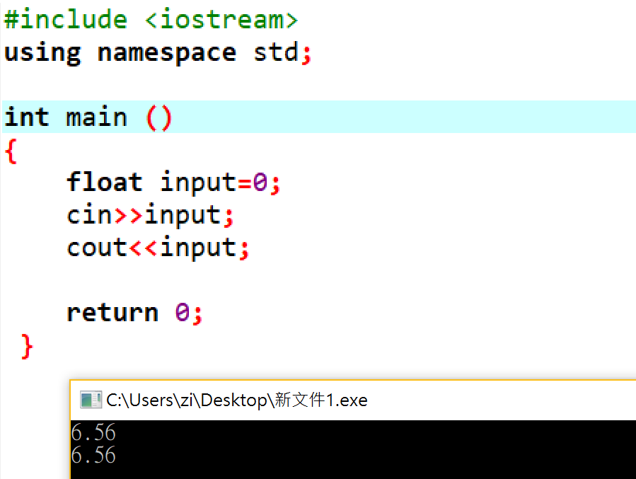

(b)

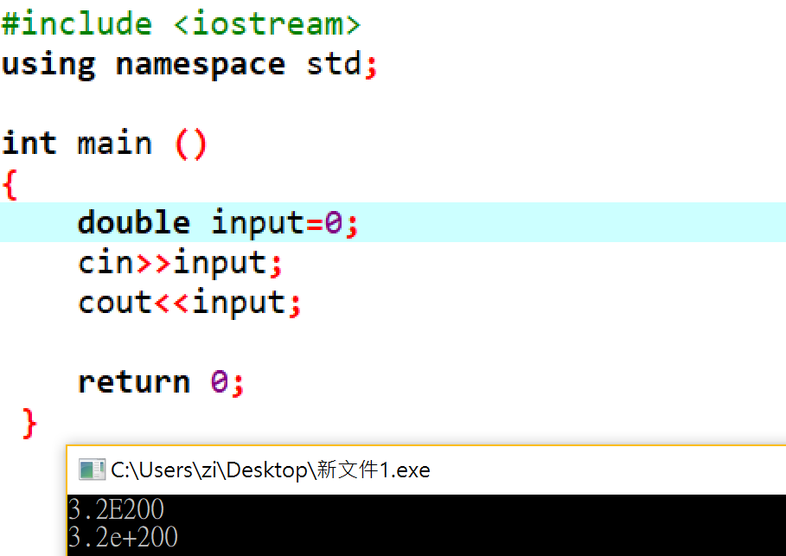

1 c

#include <iostream>

using namespace std;

int main ()

{

unsigned input=0;

cin>>hex>>input;

cout<<hex<<input;

return 0;

}

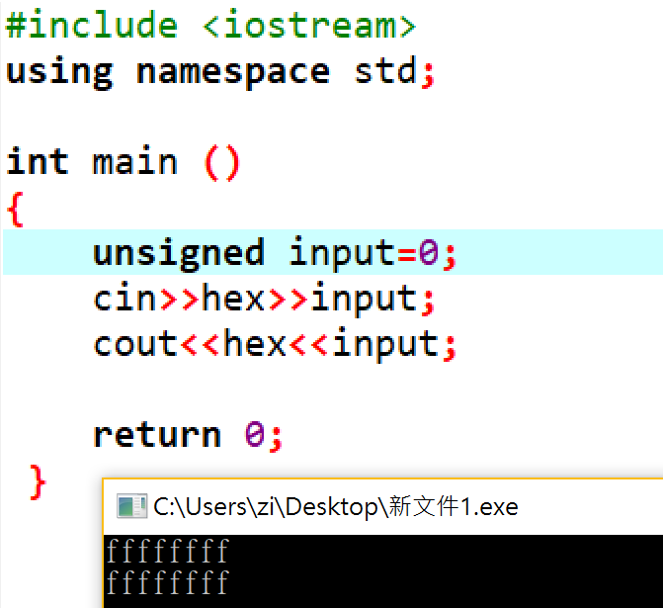

I d

#include <iostream>

using namespace std;

int main ()

{

unsigned input=0;

cin>>input;

cout<<input;

return 0;

}

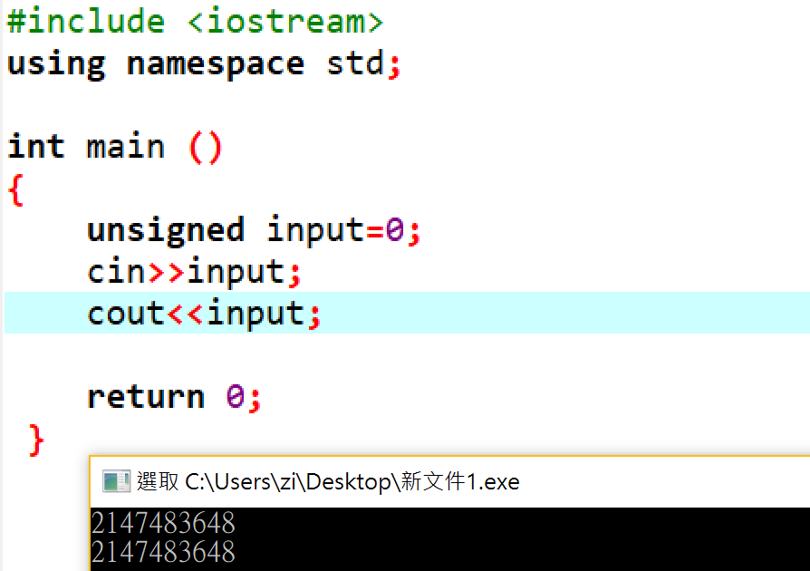

1 e

#include <iostream>

using namespace std;

int main ()

{

double input=0;

cin>>input;

cout<<input;

return 0;

}

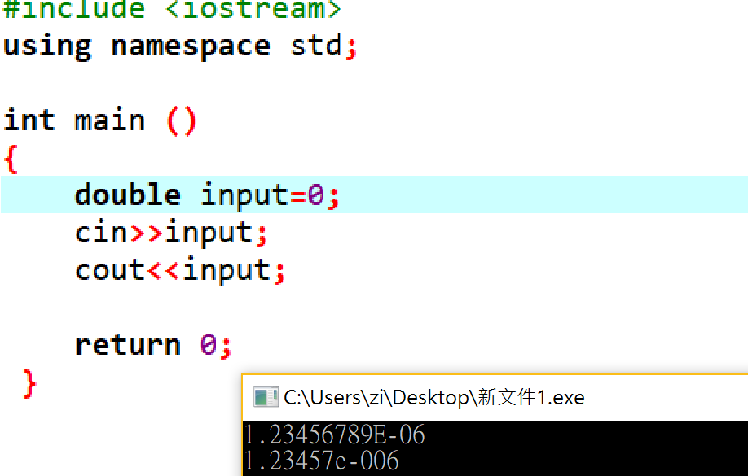

2

#include <iostream>

using namespace std;

int main ()

{

cout<<'\b'<<'\t'<<

'\\'<<'\''<<'\"'<<'\r'<<'\a';

return 0;

}

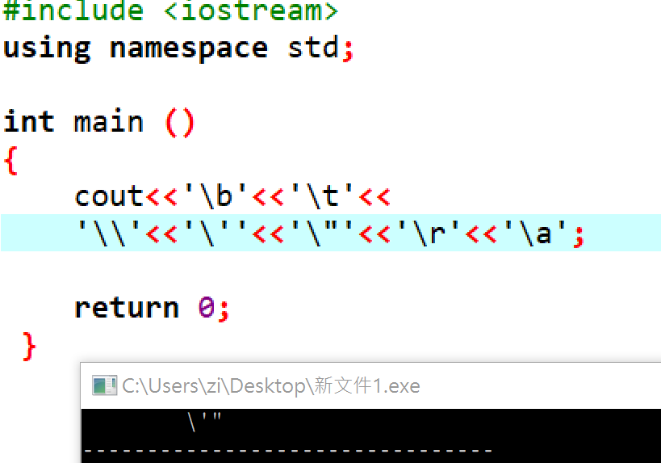

3

#include <iostream>

#include <cctype>

using namespace std;

int main()

{

char input;

cin>>input;

if(input>='A'&&input<='Z')

input = tolower(input);

else if (input>='a'&&input<='z')

input =toupper(input);

cout<<input<<endl;

return 0;

}

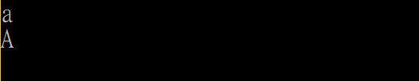

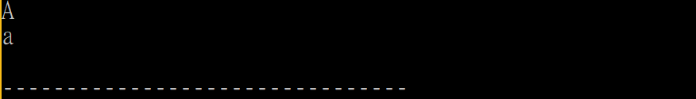

4

#include <iostream>

using namespace std;

int main ()

{

int i=0x7fffffff;

cout<<"int MAX:"<<i<<endl;

cout<<"int MIN:"<<i+1<<endl<<endl;

unsigned u=0xffffffff;

cout<<"unsigned MAX:"<<u<<endl;

cout<<"unsigned MIN:"<<u+1<<endl<<endl;

char c=0xff;

cout<<"char MAX:"<<hex<<(int)c<<endl;

cout<<"char MIN:"<<c+1<<endl<<endl;

long l=0xffffffff;

cout<<"long MAX:"<<l<<endl;

cout<<"long MIN:"<<l+1<<endl;

return 0;

}

